**ES Exp 2 – Make a Functional Design Specification**

**Part A**

## The Functional Design Specification

The document produced by the functional design phase of a project is an FDS, which spells out the functions of a proposed system, commonly expressed as what the system shall perform. The FDS also marks the point in a development project after which the nature and content of the documentation changes from user-oriented to technician-oriented.

The FDS document should include descriptions of the important systems elements, including:

* The input data and who can enter it
* The operations of each action (such as different web pages or screen displays)
* Any manual or automated workflows required by the system
* The format of output displays or reports
* If applicable, how the system conforms to any regulatory requirements

**What are Product Design Principles?**

Before providing any principles of a great product design, we need to define what actually they mean. So, let’s define what a principle and product design represent separately.

The word “principle” means “a basic idea or rule that explains or controls how something happens or works”.

Product design is a process of creating a product that aims at solving the user’s problems, needs and providing them with an effective solution.

So taking these two things into account, we may assume that product design principles are a set of rules that help teams create applications in the most efficient way possible.

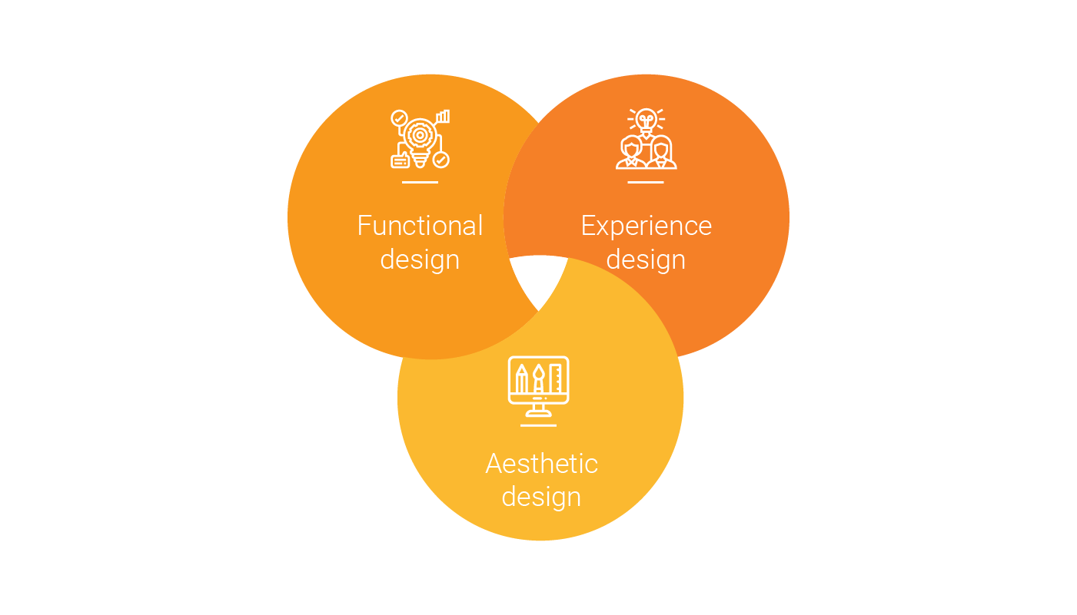

*Eight* top principles of a good product design

#### **1. Don’t Create Design, Solve the Existing Problems**

Visual design is a significant part of any app, but it’s not always of prime importance. It might sound highly improbable and ridiculous but let’s put it in a different perspective. Just imagine an Uber-like app that can’t perform its main function — help riders reach their destination points. No one would pay attention to the awesome design of the app.

A cumbersome, counterintuitive, and time consuming application can cause irritation, frustration, and disappointment, no matter how amazing it looks. Therefore, you should always think about how you can solve problems for the user in the first place.

#### **2. You are Not Your User**

We’re all sometimes inclined to forget this principle, no matter what we do. We might think that this or that feature will be quite useful in an app, but the end-user might find it out of place. And what we’ve planned might be totally pointless and impractical for them.

For this reason, we must not rely on our understanding and vision of a product. We should conduct thorough research of user behavior and tailor the product accordingly.

“Observe first, then create” — this is our motto.

#### **2. Create Simplicity and Intuitiveness**

Simplicity and intuitiveness must go hand in hand when creating product design. The user should resolve his or her pain points or problems in a simple and intuitive manner without spending much time on figuring out how the product works and what steps are needed to be undertaken to resolve a problem. Hence, we must create practical solutions for users.

#### **3. Follow UX Fundamentals**

Designers should always follow the best UX practices and avoid using non-standard and intricate ones. We believe that it’s much efficient to follow established fundamental practices that have been tested multiple times and are used every day. Thus, people get used to a familiar pattern and perception.

#### **4. Create Positive Emotions**

To create a product that is functional and appealing is a number one priority of the product designer. The other thing which is no less important is the emotional side of it. A software product should also evoke emotions and our task is to make sure these emotions are positive.

#### **5. Great Products Need Great Collaboration**

Behind every successful product stands an outstanding team, where each person thinks about all the nitty-gritty details that lead to the desired outcome. Design creation plays a vital role in the whole process of development as it heavily impacts the whole process of development. As a result, UX/UI designers, project managers, software engineers, business analysts collaborate with one another at every step of [software development](https://litslink.com/services).

What is more, each person that takes part in the product development has the app on his or her mobile phone in case someone else has any questions about the application.

That’s why collaboration is key in creating products that make a real difference.

#### **6 Use Flexible Approach**

Product designers at LITSLINK don’t use conventional approaches and patterns in creating products because every product is unique and therefore it requires to meet the individual needs of a client, end-users.Product designers also take into account specifications of each and every product.

We apply flexible approaches to create products.

#### **7. Deliverables Matters**

We do care what we ship. The final result matters a lot because we feel great pride in what we do. We work with an all-consuming passion, full involvement, and absolute commitment.

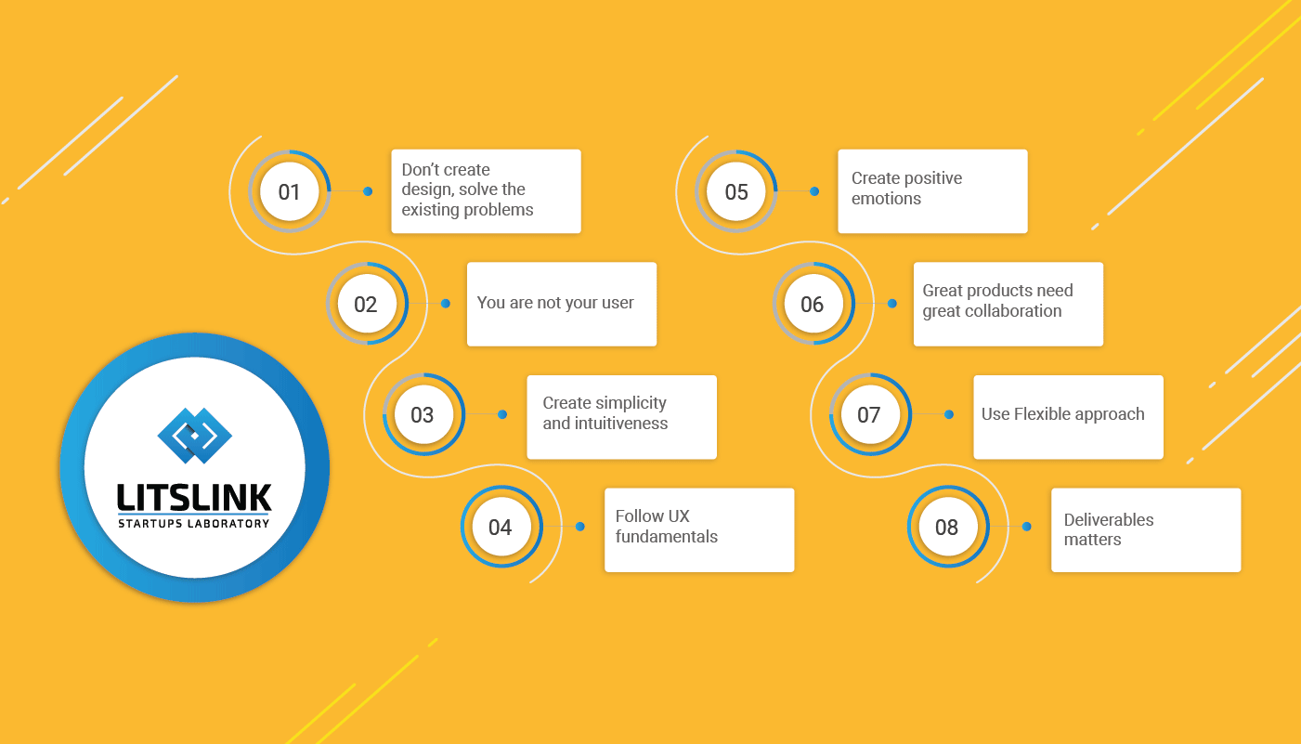

**Part B**

**Follow the above guidelines and Make a Product design for your software system**

#### **Don’t Create Design, Solve the Existing Problems**

We are creating a product that is a problem in that area cause it’s an remote area and by which there is a necessary to create a system that solves the existing problem which is no availability of modern devices in the area and if there then there is no proper communication signals.

#### **You are Not Your User**

Since it’s a product for a remote location we have made a survey in that area and found out that the area where we are making our store is the best suited for all the people in that location, and its geographical factors make it the best suitable location.

#### **Create Simplicity and Intuitiveness**

By creating a cybercafe for the people at that area and with the fact that we are in the 21st century it’s a given fact people know how to solve their problem and how to get out of any issue they faced and if there is an issue which they are facing and not able to solve by them there is a admin available there who can help you with solving of the issue.

#### **Follow UX Fundamentals**

We have a created a minimalistic system which they can use on daily basis and the management system which we are establishing helps in easy managing the systems by the admin and it let them know which systems are free and which systems are facing issue and it requires their help.

#### **Create Positive Emotions**

We have created a system where we have made sure that the application is clear and easy to use giving the emotion of the user positive and helps in recurring customer base.

#### **Great Products Need Great Collaboration**

As the name suggest, we have created a system which requires a help of Networking, User experience, Management systems cause given the scenario this is the one which are helping in making a great product by the help of great collaboration.

#### **Use Flexible Approach**

We use a system that’s best suited for this scenario and there are some processes which are traditional but some are just new and catered on the basis of the scenario.

#### **Deliverables Matters**

We have created a system that’s well suited for people at that area cause if the system is a complex one and then people are not suited for that then it may lead to loss of the project, that’s why we have created a system that’s well suited for the area.